SUPPLEMENTAL FIGURES

Figure S1. Schematic of Anopheles mosquito embryo collection and CRISPR/Cas9
microinjections. Anopheles takes 12 days mature from egg to adult (i), Fresh Anopheles embryos were collected (ii), aligned (iii), and injected with CRISPR/Cas9 components (v) Injected embryos were then gently put into the water for development (6 days), and emerged G0 adults were subsequently screened for CRISPR/Cas9 induced mutations in target gene (vi). This entire procedure takes roughly 18 days to complete.

Figure S2. Anopheles mosquito crossing strategies. (A) Anopheles coluzzii mutant G0 cross with white-eye mutant line (M2). (B) Anopheles albimanus and Anopheles funestus mutant G0’s were inbred.

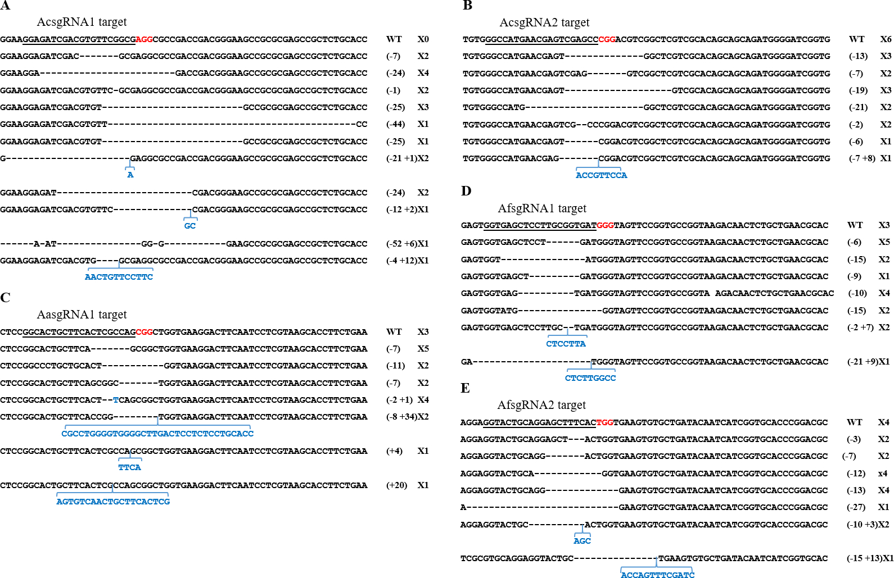
Figure S3. Repair of CRISPR-induced double strand breaks results in a variety of indels. Sequencing of cloned PCR products from G₀ injected mosquitoes possessing mosaic eyes revealed a variety of insertions and deletions adjacent to the guide target site. For each sgRNA, top line represents WT sequence; PAM sequences (NGG) are indicated in red, and gene disruptions resulting from insertions/deletions are indicated in blue/dash.

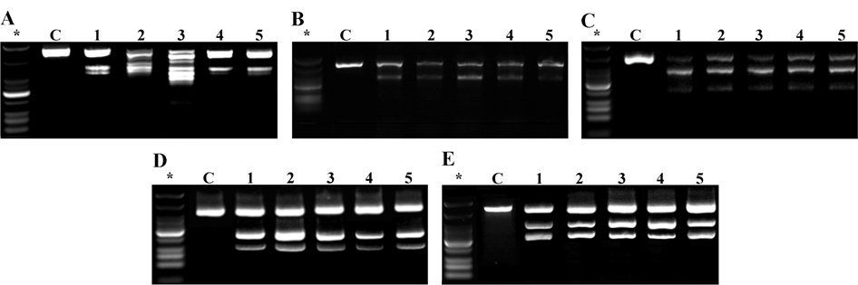

Figure S4. The T7 Endonuclease assay can be used for rapid detection of CRISPR-generated mutant alleles. For each successful guide RNA (A, AcsgRNA1; B, AcsgRNA2; C, AasgRNA1; D, AfsgRNA1; E, AfsgRNA2), PCR products from non-mosaic (C) and mosaic (1-5) mosquitoes were digested with T7 endonuclease. In all mosaic mosquitoes, partial digestion of the PCR product is evident, while in non-mosaic mosquitoes no digestion is visible.

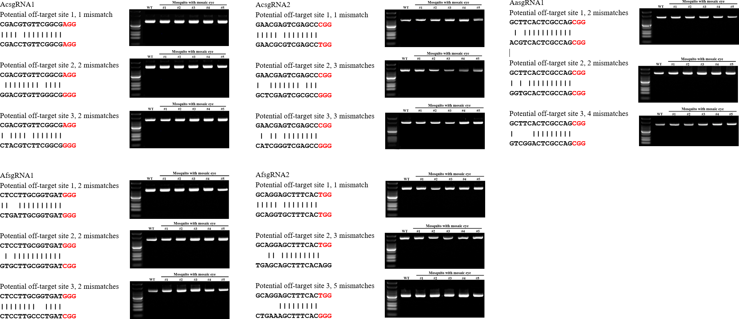

Figure S5. No evidence for off-target mutagenesis of sgRNAs. Three potential off target sites for each sgRNA were screened for mutagenesis activity by T7 endonuclease assay. PAM distal region sequence alignment of target locus and potential off-target loci. The potential off-target sites of sgRNAs in different Anopheles mosquitoes are indicated, and the PAM sites are labeled in red. T7 Endonuclease I (T7E1) assay of potential off-target loci. “WT” represented wild type mosquito, number from 1 to 5 indicated 5 different mosquitos with mosaic eye phenotype. No digestion is visible in any of the lanes.

Table S1. Primers used in this study.
Species | Primer name | Primer sequence (5'-3')
A. coluzzii | sgRNAF1 | GAAATTAATACGACTCACTATAGGAGATCGACGTGTTCGGCGGTTTTAGAGCTAGAAATAGC
 | PCRF1 | TGGAAGCTTGCTTGGGATAG
 | PCRR1 | GTCAGCGACGGTATGAACAG
 | sgRNAF1off-targetF1 | AACCACTGTCTGCTGAACTC
 | sgRNAF1off-targetR1 | GACAGGAACTCGCCCAAATA
 | sgRNAF1off-targetF2 | TCTTCCAGACGTACCTCGAT
 | sgRNAF1off-targetR2 | GGTGCTCGTTGAAGCTGTA
 | sgRNAF1off-targetF3 | TCCTCGAGCACGCAAATATC
 | sgRNAF1off-targetR3 | CCCGTTCTGGAAGTTGTACTC
 | sgRNAF2 | GAAATTAATACGACTCACTATAGGCCATGAACGAGTCGAGCCGTTTTAGAGCTAGAAATAGC
 | PCRF2 | AAACCTGCCCAACACCAT
 | PCRR2 | TAAGAGCCTGAGAGCCTGAC
 | sgRNAF2off-targetF1 | CACACCCAGAGCACATACAA
 | sgRNAF2off-targetR1 | GATCAGCGCGACGATATTCA
 | sgRNAF2off-targetF2 | GGCGATATGAAGCTCAAGGTA
 | sgRNAF2off-targetR2 | AAGGGATGACTGTCAATGGG
 | sgRNAF2off-targetF3 | CAGGTAGAGCGTGTTGATGTT
 | sgRNAF2off-targetR3 | GTTGTCCTCTCTAGAAGGGTTTATT
A.albimanus | sgRNAF1 | GAAATTAATACGACTCACTATAGGCACTGCTTCACTCGCCAGGTTTTAGAGCTAGAAATAGC
 | PCRF1 | AAGAGTTACGGTTCGGTGAAG
 | PCRR1 | AACATCAGGTGCTCCTTGG
 | sgRNAF1off-targetF1 | TCCACATACAGAATCCACTCAAC
 | sgRNAF1off-targetR1 | GTTCGGTCTCTTCTTGCTTCA
 | sgRNAF1off-targetF2 | GGCCGAGCAAAGTCAACA
 | sgRNAF1off-targetR2 | TGCTGAGCTACATTACGGTTTC
 | sgRNAF1off-targetF3 | TCTCAATCTACACACGGGAAAC
 | sgRNAF1off-targetR3 | ATGGATCTGGCGATCAAGAAG
 | sgRNAF2 | GAAATTAATACGACTCACTATAGGCTAGCGCGTTCAGCAGCGGTTTTAGAGCTAGAAATAGC
 | PCRF2 | GACAAGGCCACGCTGATAC
 | PCRR2 | TCCTGCAGTACCTCGTCAA
A. funestus | sgRNAF1 | GAAATTAATACGACTCACTATAGGTGAGCTCCTTGCGGTGATGTTTTAGAGCTAGAAATAGC
 | PCRF1 | GAAGAGCTACGGTTCGGTTAAG
 | PCRR1 | GGCTGGTGTATGGTGAGTATG
 | sgRNAF1off-targetF1 | CGGTGAATGTGTGCAGTTTG
 | sgRNAF1off-targetR1 | CGCTATTATAGTGGCACTGAGG
 | sgRNAF1off-targetF2 | GTCAATCTTCTCCTCGGATAGTG
 | sgRNAF1off-targetR2 | GCGAGATTCGACGTTTGATAAAG
 | sgRNAF1off-targetF3 | GTCAATCTTCTCCTCGGATAGTG
 | sgRNAF1off-targetR3 | GCGAGATTCGACGTTTGATAAAG
 | sgRNAF2 | GAAATTAATACGACTCACTATAGGTACTGCAGGAGCTTTCACGTTTTAGAGCTAGAAATAGC
 | PCRF2 | GAAGAGCTACGGTTCGGTTAAG
 | PCRR2 | GGCTGGTGTATGGTGAGTATG
 | sgRNAF2off-targetF1 | CGATGAGCGAAGAGTCCAAA
 | sgRNAF2off-targetR1 | TACCCAGCTGTGAAGCAATC
 | sgRNAF2off-targetF2 | CGTGTGGTCGCTTGGAATAA
 | sgRNAF2off-targetR2 | CGCTGGTAAGTTGGTGGTAAA
 | sgRNAF2off-targetF3 | CCTACCGCCAGGAATGTAATG
 | sgRNAF2off-targetR3 | GGACCGAGGCTGAAATGTTAT
 | Universal-sgRNAR | AAAAGCACCGACTCGGTGCCACTTTTTCAAGTTGATAACGGACTAGCCTTATTTTAACTTGCTATTTCTAGCTCTAAAAC

Table S2 In silico-prediction of microhomology-associated DNA repair
sgRNA | Target | Deletion length% | Microhomology score&
AcsgRNA1 | GGAGATCGACGTGTTCGGCG | 3 - 53 | 5878.3
AcsgRNA2 | GGCCATGAACGAGTCGAGCC | 6 - 57 | 5654.9
AasgRNA1 | GGCACTGCTTCACTCGCCAG | 4 - 51 | 5177.2
AfsgRNA1 | GGTGAGCTCCTTGCGGTGAT | 6 - 53 | 5028.7
AfsgRNA2 | GGTACTGCAGGAGCTTTCAC | 6 - 54 | 3755.8

% In silico (http://www.rgenome.net/mich-calculator/) predicted deletion length mediated by CRISPR/Cas9
& The sum of pattern scores, which associated with microhomology deletion patterns (Bae. et al, 2014)

Bae, S. J Kweon, H. S. Kim and J.S. Kim, 2014 Microhomology-based choice of Cas9 nuclease target sites. Nat. Med. 11: 705-706

